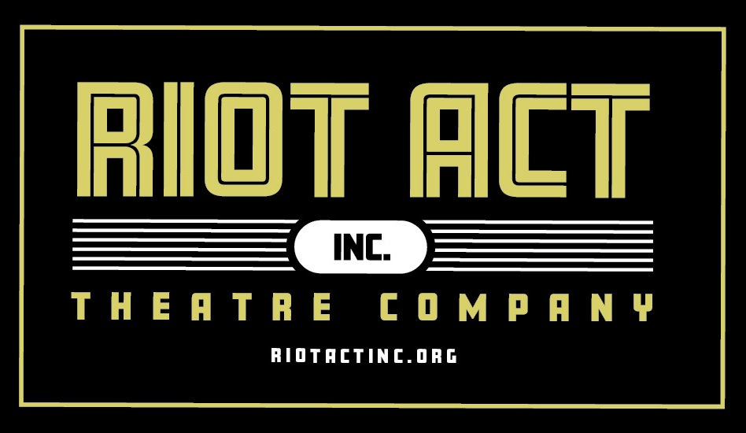

New Play Festival Guidelines

Deadline and Submission Fee
$20 per entry. All entries must be submitted no later than July 15, 2020 by 5pm Mountain Time.

Basic requirements
· Plays should run 20-30 minutes total (20 to 30 pages.)
· Plays should require no more than six actors total.
· Set and prop concepts should be simple and must be easily broken down and moved. No more
than 1 set change or 2 sets total allowed.
· Entries will be accepted from playwrights residing in the regional areas of WY, ID, UT, CO and MT.
· Plays must have not been previously published or produced within the past 5 years or in any of the
resident states.
(Plays previously submitted may be resubmitted if reworked based on commentary received in previous years.)

Format requirements
· Please provide 2 copies of your play, one with playwright information included and one without.
(Judges read the plays blindly, so we need a copy with no playwright information to give to the judges.)
· Title page should include the play title, playwright’s name and full contact information.
· Subsequent pages should include page numbers and play title in a header or footer.
· DO NOT include playwright’s name in header or footer.
· Body of the play should be no more than 30 pages long, double spaced, with a 10- to 12-point font.
· Unfamiliar with play formatting? Please visit www.playwriting101.com/chapter06 for more
information and examples.
· No revisions will be allowed after the audition and rehearsal process begins.

All plays must be submitted electronically with a registration form as either a Word file or as a PDF. Registration fees may be paid by credit card on the Riot Act, Inc., website or by check or money order mailed to Riot Act, Inc. Please email all submissions to NewPlayFest@riotactinc.org.

Three finalists will be chosen, and winners notified no later than July 31, 2020. Playwright contracts must be signed before winners announced. The winning plays will be produced as part of the Riot Act, Inc.’s Series of Shorts September 2020. The selection of directors and actor auditions will be held in early August 2020. Rehearsals will run from August to performances in September 2020.

For more information email NewPlayFest@riotactinc.org or check our website at www.riotactinc.org.

**While we plan to move forward with performances as scheduled, if COVID issues cause live performances to be canceled, we will discuss alternatives.**

